# JS Essentials - Exam Preparation II

Exam problems for the [“JavaScript Essentials” course @ SoftUni](https://softuni.bg/courses/js-essentials). Submit your solutions in the Softie Judge system at <https://judge.softuni.bg/Contests/Practice/Index/1675#2>.

## Problem 3. Warehouse Machine

*Here is your final task. You must manage the storage of a coffee warehouse. You need to be able to add and sell coffee products and do some revisions and inspections.*

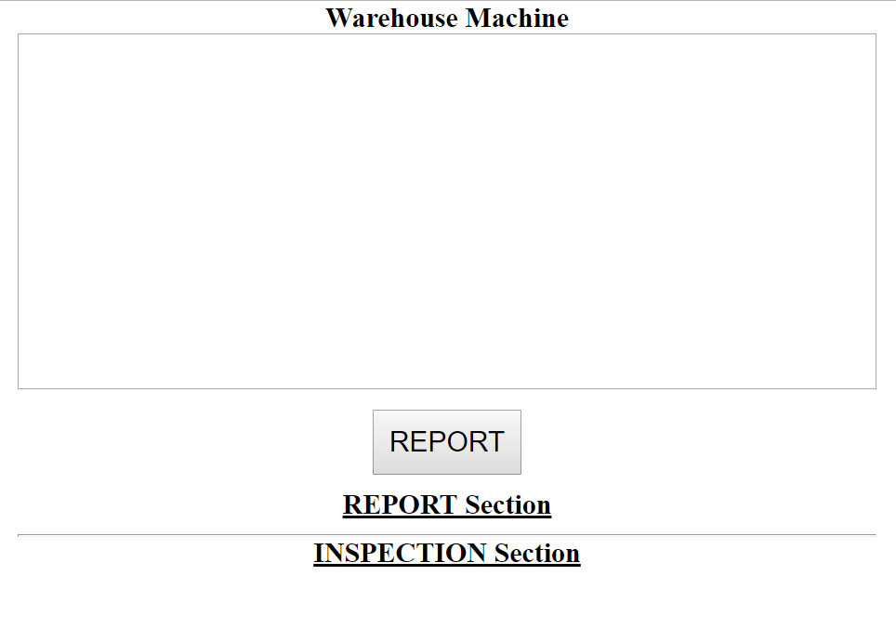

You need to **store coffee brands** and for **each brand** you store different **coffee** (**name, expire date and quantity**). **You can use strings to compare the date, not the Date class.** The **input** is an **array of strings**. Each string contains information about what you need to do. The **first part** will be the **'command'**. It can be some of the following:

* **'IN'** – you need to **add coffee products**
* **'OUT'** – you need to **unload coffee products**
* **'REPORT'** – print **all the products in the warehouse as they were passed in the input**
* **'INSPECTION'** – print all the **products SORTED**
* **'REPORT' command:**Print **all brands with all the coffee** in the following format: **'{nameOfBrand1}: {coffeName1} - {expireDate} - {quantity}. {coffeName2} - {expireDate} - {quantity}. {coffeName} - {expireDate} - {quantity}.  
  {nameOfBrand2}: {coffeName1} - {expireDate} - {quantity}. {coffeName2} - {expireDate} - {quantity}. {coffeName} - {expireDate} - {quantity}.'**  
  Each brand must be in the new line. Use "**<br>"** **element** to do that.
* **'INSPECTION' command:**Same as the 'REPORT' command, but the **brands** should be **sorted alphabetically** and for each brand the **coffee should be sorted by quantity in descending order**. Print in the following format: **'{nameOfBrand1}: {coffeName1} - {expireDate} - {quantity}. {coffeName2} - {expireDate} - {quantity}. {coffeName} - {expireDate} - {quantity}.  
  {nameOfBrand2}: {coffeName1} - {expireDate} - {quantity}. {coffeName2} - {expireDate} - {quantity}. {coffeName} - {expireDate} - {quantity}.'**  
  Each brand must be in the new line. Use "**<br>"** **element** to do that.
* **'IN' command:  
  Example: ' IN, Lavazza, Crema e Gusto, 2023-05-01, 5'**. You get the **coffee brand**, next you get the **name of the coffee**, then the **expire date** and the **quantity**.   
  - If this is the **first time you receive this brand** of coffee, **add it in the storage**, then **add the coffee with all of the other info**- If the **brand already exists in the storage**, but the **coffee does** **NOT**, **add the coffee to the brand with all of its info**  
  - If the **brand and the coffee exist**, check the date. If the **new coffee expires later than the old one, replace it**. If they are equal, just **add the new quantity to the old one**. **Otherwise, do nothing.**
* **'OUT' command:  
  Example: ' OUT, Lavazza, Crema e Gusto, 2023-05-01, 2'**. Check for the **brand and the coffee**. If you **have them in storage**, check if you have some that **expires after the given date** and check if you **have the quantity needed**. If you have, **remove that quantity** of that coffee from the storage.

### Input

* **An array of strings**
* **Example:**
  + **["IN, Batdorf & Bronson, Espresso, 2025-05-25, 20","IN, Folgers, Black Silk, 2023-03-01, 14","IN, Lavazza, Crema e Gusto, 2023-05-01, 5","IN, Lavazza, Crema e Gusto, 2023-05-02, 5","IN, Folgers, Black Silk, 2022-01-01, 10","IN, Lavazza, Intenso, 2022-07-19, 20","OUT, Dallmayr, Espresso, 2022-07-19, 5","OUT, Dallmayr, Crema, 2022-07-19, 5","OUT, Lavazza, Crema e Gusto, 2020-01-28, 2","REPORT","INSPECTION"]**

### Output

* When you get the command '**REPORT'** or **'INSPECTION'** you should print the **right** **result** in the corresponding element:  
  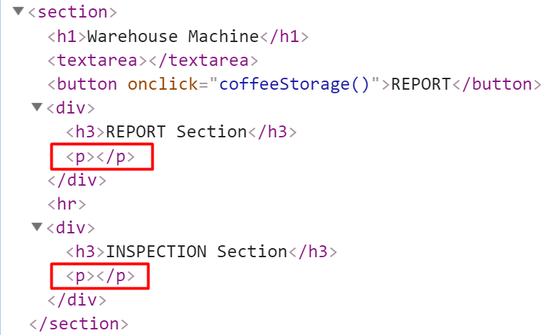

### Example

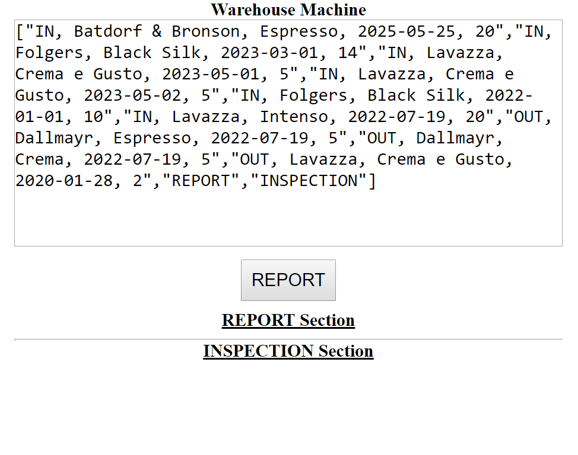

After clicking "**REPORT**" button:

